**DEVOE’S CHAIR**

**An Engineering Project in Community Service**

**Phase – II Report**

***Submitted by***

**18BEC10037 - Khushi Rathore**

**18BEC10084 - Sushant Sharma**

**18BEC10088 - Utkarsh Gupta**

**18BEC10007 - Anjali Prajapati**

**18BCE10074 - Ayushi Jaimani**

**18BCE10247 - Shikhar Srivastava**

**18BCG10022 - Anutej kardele**

***in partial fulfillment of the requirements for the degree of***

***Bachelor of Engineering and Technology***



**VIT Bhopal University**

**Bhopal**

**Madhya Pradesh**

**August 2020 – May 2021**



**Bonafide Certificate**

Certified that this project report titled **“DEVOE’S CHAIR”** is the bonafide work of “18BEC10037 - Khushi Rathore ,18BEC10084 - Sushant Sharma, 18BEC10088 - Utkarsh Gupta,18BEC10007 - Anjali Prajapati,18BCE10074 Ayushi Jaimani, 18BCE10247 - Shikhar Srivastava, 18BCG10022 - Anutej kardele**”** who carried out the project work under my supervision.

This project report (Phase II) is submitted for the Project Viva-Voce examination held on May 27,2021.



**Supervisor**

**(Susant Panigrahi)**

**Comments & Signature (Reviewer 1)**

**Comments & Signature (Reviewer 2)**

**Introduction**

Assistive technology is essential for elderly and disabled communities to help in daily living activities, socialization, and traveling. It is also known that robotic application in medical mobility can provide a better life for the people with both lower and upper extremity impairments. While assistive robotic technology is progressing rapidly to improve the mobility of people, several challenges remain to make this technology truly usable by humans. One important aspect that requires research development is defining the control protocols between the human and the robot technology. There are different types of wheelchairs including basic, lightweight, folding, multi-function, powered, fully/partially autonomous and so on. And there are many types of control design to manipulate the functionality of the wheelchair, from basic drive to fully controlled wheelchair using a brain-controlled interface. However, the power wheelchair users frequently report accidents, therefore our focus is to advocate the use of robotic technology, in particular sensor-based detection and navigation using smart wheelchairs.

Smart wheelchairs are generally equipped with sensors, cameras and computer-based systems as the main processing unit to be able to perform specific tasks. Autonomous smart wheelchairs are controlled by a human user interface where the human makes decisions at the highest level of operation and the smart control technology makes the rest of the motion automatic. The advances in autonomous smart wheelchairs are embedded with computers and focus heavily on the computer cluster architecture. The intelligence is added to a wheelchair platform around user control despite their disabilities, which makes the study of the human-machine interface (HMI) between the user and the wheelchair an important assistive robotic field of study. Standard electric powered wheelchair has little computer control with some level of motor control using a joystick.

The autonomous navigation capabilities of the smart wheelchair including perception, localization, path planning, and motion control, operate in the LabVIEW software environment. The path planning and motion control programs are optimized for the differential drive wheelchair platform. Small form factor (SFF) computers are connected over LAN with an Ethernet switch to explore the benefits of HPC cluster for real time sensor data processing and autonomous navigation. Network automation is used to enhance control of the LabVIEW programs to simplify the user interface. A touch screen monitor user interface connects to the client computer for software system access. A real time performance monitor is incorporated into the user interface to provide sensor data visual feedback and track the status of the LabVIEW programs on the computer cluster during smart wheelchair operation.

**Objective:**

This chair is the future of care services around the globe, be it day-care for children or old age homes for elderly people.The chair provides comfort and security to anyone who is in a need to carry out the basic day to day life activities.

**Motivation:**

We got motivated through the daily lifestyle of handicapped people, they feel a burden to their loved ones.This chair is designed to make them feel like a normal human being who is able to do their work themselves.This chair is the future of care services around the globe, be it day-care for children or old age homes for elderly people.The chair provides comfort and security to anyone who is in a need to carry out the basic day to day life activities. A smart wheelchair can restore autonomy to patients with sensori-motor disabilities by enabling them to move around freely without depending on the caregivers. The objective of a smart wheelchair is to reduce user effort in controlling the wheelchair and to ensure safety during movement. In this paper, our focus is to design and develop a smart wheelchair using inexpensive hardware and open-source software so as to make it affordable to a larger section of the target population, particularly in developing nations. The user can control the wheelchair using three interfaces namely, keyboard, a webcam and a microphone. Webcam is used to detect head-tilt which can be used for turning the wheelchair. Microphone is used for controlling the wheelchair through discrete voice commands. The wheelchair can be operated in three modes namely, manual, automatic and tele-operation modes. The software and hardware architecture of the platform is described in detail and experiments are performed to demonstrate the usability of the platform.

**Existing Work/Literature Review**

Omni + module (Permobil and Jazzy) or QTronix Universal Specialty Controls Module (Sunrise Medical). For Invacare wheelchairs, the SWCS uses the switch joystick interface provided by the digital drive box.The promised advantage of the add-on unit approach is that a consumer will be able to buy the system once and transfer it to multiple chairs over their lifetime. This is particularly important for children, who may go through several wheelchairs in a short period of time as their bodies grow. The add-on approach also lends itself more readily to flexible configurations of sensors and input devices based on each individual user’s needs.Currently, only two smart wheelchairs are based on manual wheelchairs. The Collaborative Wheelchair Assistant (manual) controls the direction of a manual wheelchair with small motorized wheels that are placed in contact with the wheelchair’s rear tires to transfer torque to the rear wheels. The SPAM uses pushrim activated,power-assist wheelchair hubs in place of traditional rear wheels. Despite a long history of research in smart wheelchairs,very few smart wheelchairs are currently on the market . Two North American companies,Applied AI Systems, Inc., Ontario, Canada, and Activ-Media, Amherst, New Hampshire, sell smart wheelchair prototypes for use by researchers, but neither system is intended for use outside of a research lab. The Communication Aids for Language and Learning (CALL) Center smart wheelchair is sold in Europe by Smile Rehab, Ltd.,(Berkshire, United Kingdom) as the “Smart Wheelchair.”The “Smart Box,” which is also sold by Smile Rehab, is compatible with wheelchairs that use either Penny Giles or dynamic control electronics and includes bump sensors (but not sonar sensors) and the ability to follow tape tracks on the floor. Limited commercial availability has resulted in limited clinical impact as well.

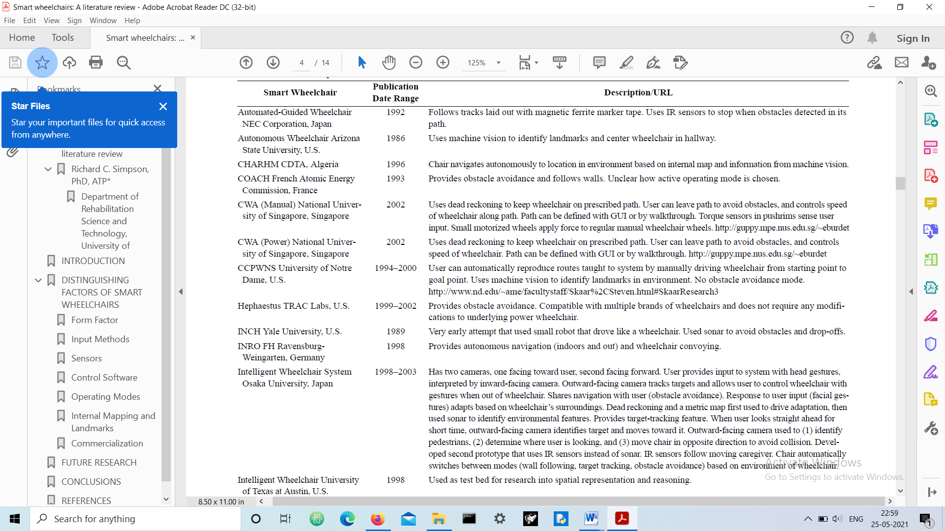

**Topic of the Work**

**System Design / Architecture**

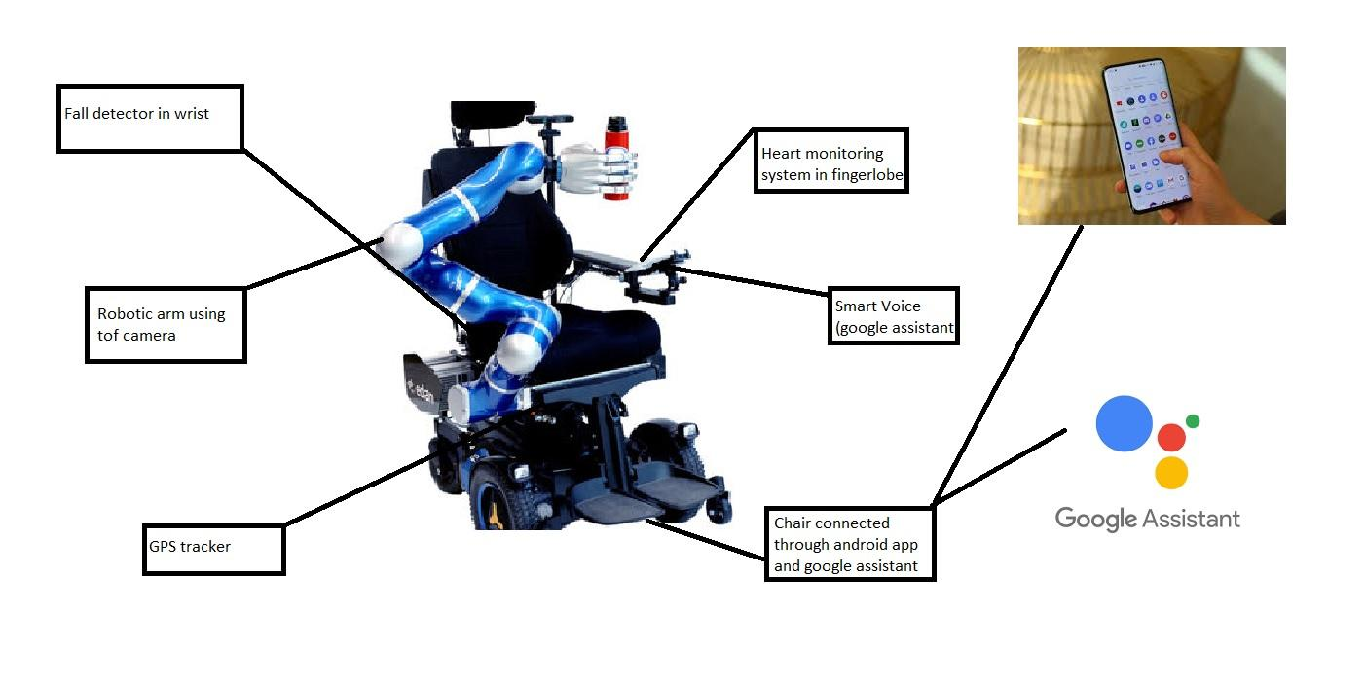

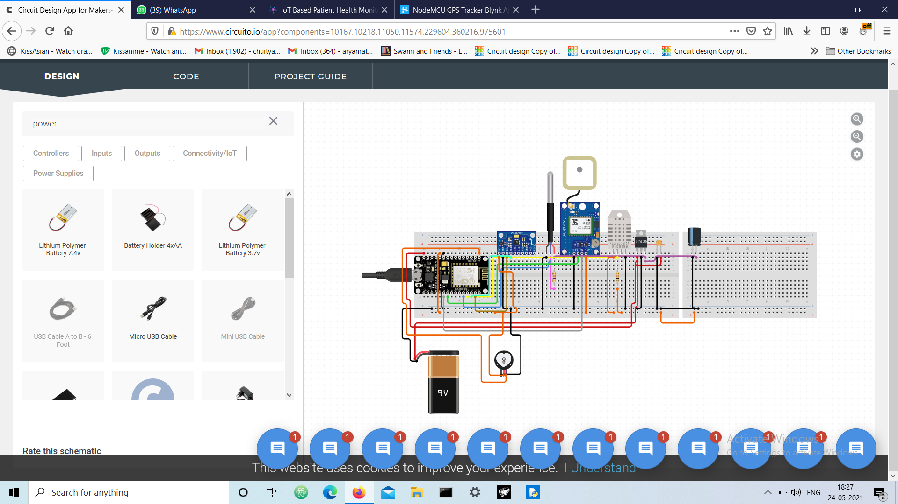

**Circuit diagram of Health Monitoring,GPS Tracker and Fall Detection System using Nodemcu**

**Working Principle**

**Module 1: Home automation System**

ESP-32 is a series of low-cost and low-power system-on-chip (SoC) microcontrollers with integrated Wi-Fi and dual-mode Bluetooth. The microcontroller is cheap with low-power consumption and a great number of pins. Evidently, with its varied features, IoT becomes easier when it comes to ESP-32. Our project is automation using ESP-32 over a local web server. On a local web server, we do not require Internet and handling everything over Wi-Fi is possible. Here, we will be handling the Input-Output pins and switching relays on a web page of the local server. We can connect our home appliances with the Relay Module that will be driven by ESP-32. Relay is also a switch that connects or disconnects two circuits. But instead of manual operation a relay is applied with electrical signal, which in turn connects or disconnects another circuit.

Components Required: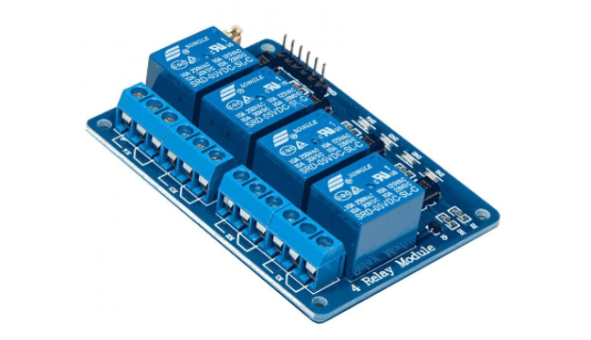

Esp32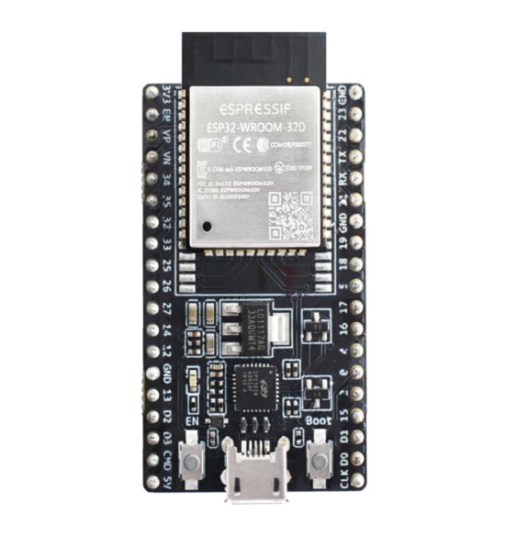

Relay

Light,fan

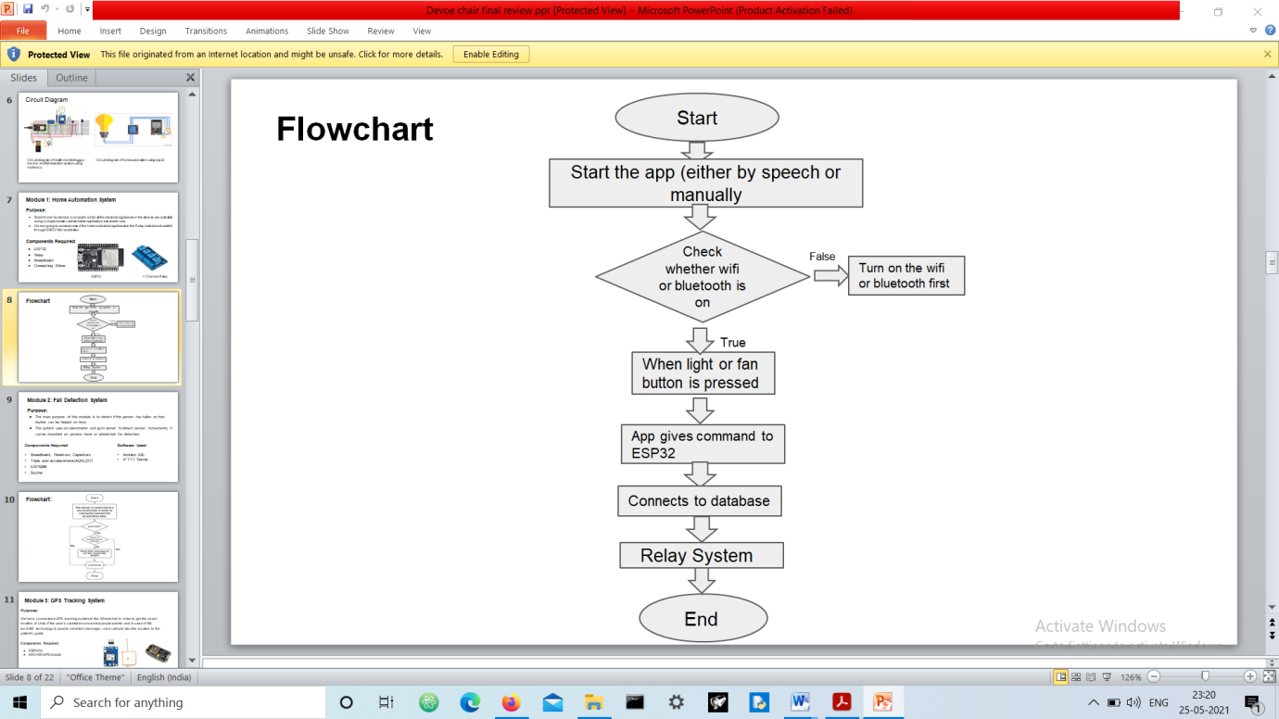

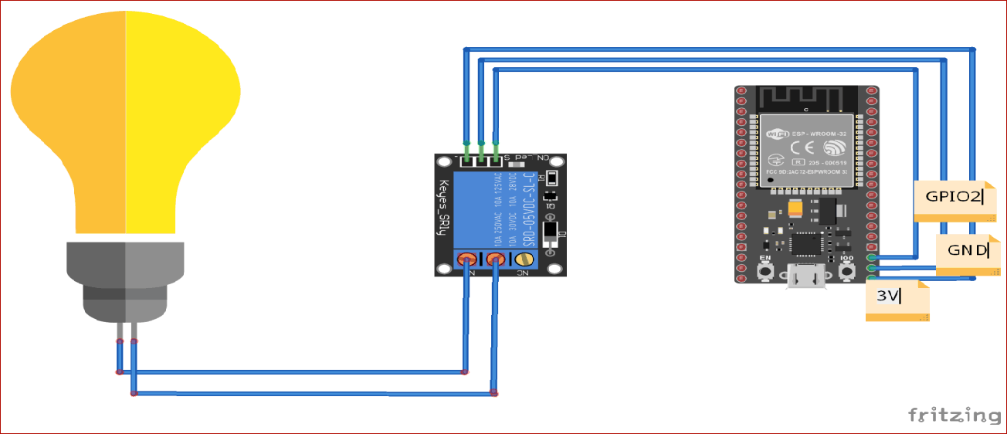

**Circuit Diagram and flowchart of Home automation System**

**Module 2: Fall detection System**

MPU6050 sensor module features a gyroscope and an accelerometer. The gyroscope is used to determine the orientation and the accelerometer provides information about the angular parameter such as the three-axis data. To detect the fall, we will compare the acceleration magnitude with the threshold value. If the fall is detected, the device will send an SMS to the concerned person. NodeMCU is used here as a microcontroller and Wi-Fi module to connect with IFTTT to send SMS. The MPU6050 works on the I2C protocol, so we only need two wires to interface NodeMCU and MPU6050. The SCL and SDA pins of MPU6050 are connected to D1 and D2 pins of NodeMCU, while VCC and GND pins of MPU6050 are connected to 3.3V and GND of NodeMCU.

The MPU6050 is a Micro Electro-Mechanical Systems (MEMS) which consists of a 3-axis Accelerometer and 3-axis Gyroscope inside it. This helps us to measure acceleration, velocity, orientation, displacement and many other motion related parameters of a system or object.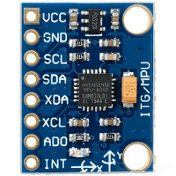

Components Required: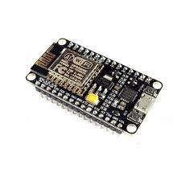

Breadboard, Resistors, Capacitors

MPU6050 Gyroscope Accelerometer Sensor

ESP8266

Buzzer 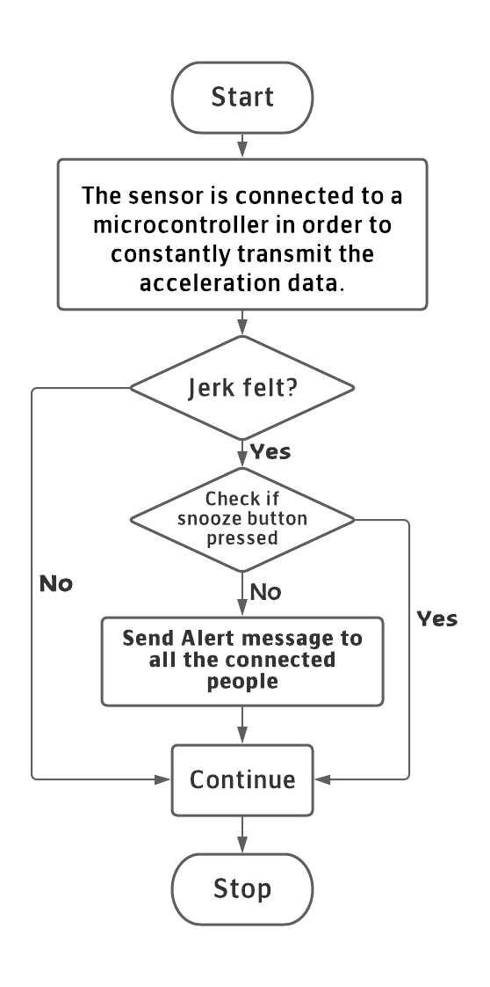

**Flowchart of Fall Detection System**

**Module 3: Gps Tracker**

The main idea of GPS systems is to determine the location of a certain object or person in real time. GPS tracking systems utilize the global navigation satellite system (GNSS) network. Each of these satellites in orbit sends microwave signals to a receiver. The receiver then uses these signals to calculate your precise location from at least four of the GPS satellites. Finally, your location is determined once the system triangulates your exact position on the planet to the nearest meters based on these distances.

The process follows a simple mathematical principle called trilateration. To complete the mathematical calculation, GPS receivers use the accurate position of at least 4 satellites and the distance to each to estimate 4 values: earth latitude, earth longitude, elevation and time. The position and distances to a given satellite determines the position of the receiver. The accurate position of a satellite is repeatedly transmitted to all receivers in line of sight and usually requires open sky. The distance to a satellite is found by the precise time the satellite transmission arrives at the receiver. The time generated by each satellite’s atomic clock is transmitted by the satellite at preset intervals.

The microprocessor on the device will calculate its location and transmit the concluded data to a server over the Internet using the worldwide GSM cellular network. That server hosts a platform that end users can access and view the device’s current and past historical path, speed and alerts. All this data is then served via the internet and displayed on an end user device using a desktop app or to a smart phone using iPhone or Android app.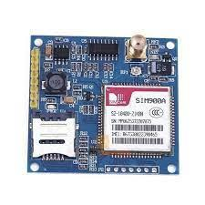

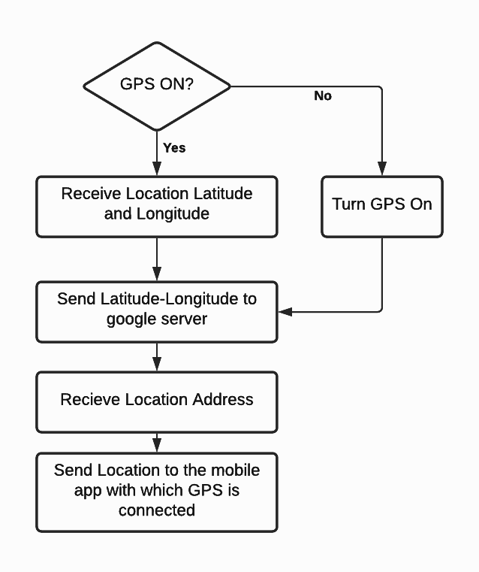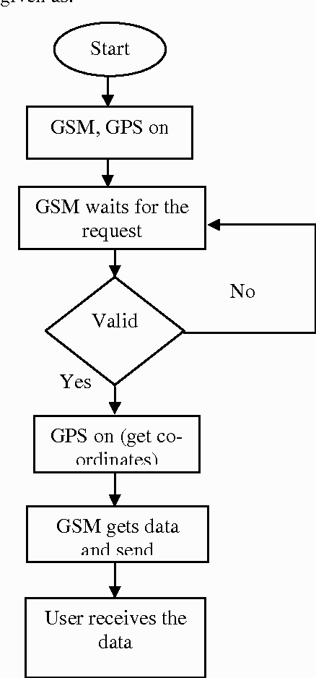

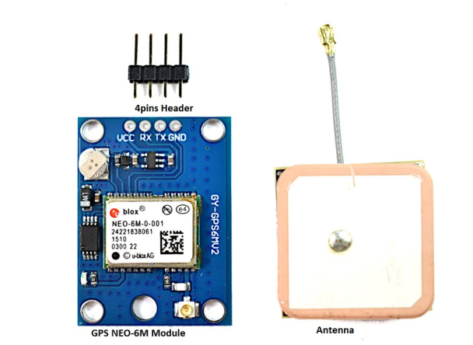

**Flowchart of GPS and GSM**

**Module 4: Health Monitoring System**

Our equipment uses a smart web server to track patient health using this tracking system. Hence, patient health parameters such as body temperature, heart rate, blood oxygen levels as well as room temperature and humidity can be monitored.

Component Required:

MAX30100/102 Pulse Oximeter Its main function is to read the absorption levels for both light sources and store them in a buffer that can be read via I2C. The oxygenated blood absorbs more infrared light. Hence, it passes more red light while deoxygenated blood absorbs red light and passes more infrared light.

DS18B20 sensor- Useful when you need to measure something far away, or in wet conditions. The sensor can measure temperatures from -55 to 125°C (-67°F to +257°F). Actually, the cable of this sensor is jacketed in PVC.

The DHT11 is a simple, ultra-low-cost digital temperature & humidity sensor. DHT11 uses a capacitive humidity sensor and a thermistor to measure the surrounding temperature and humidity. It sends data in digital signal form so no analog input pin is required.

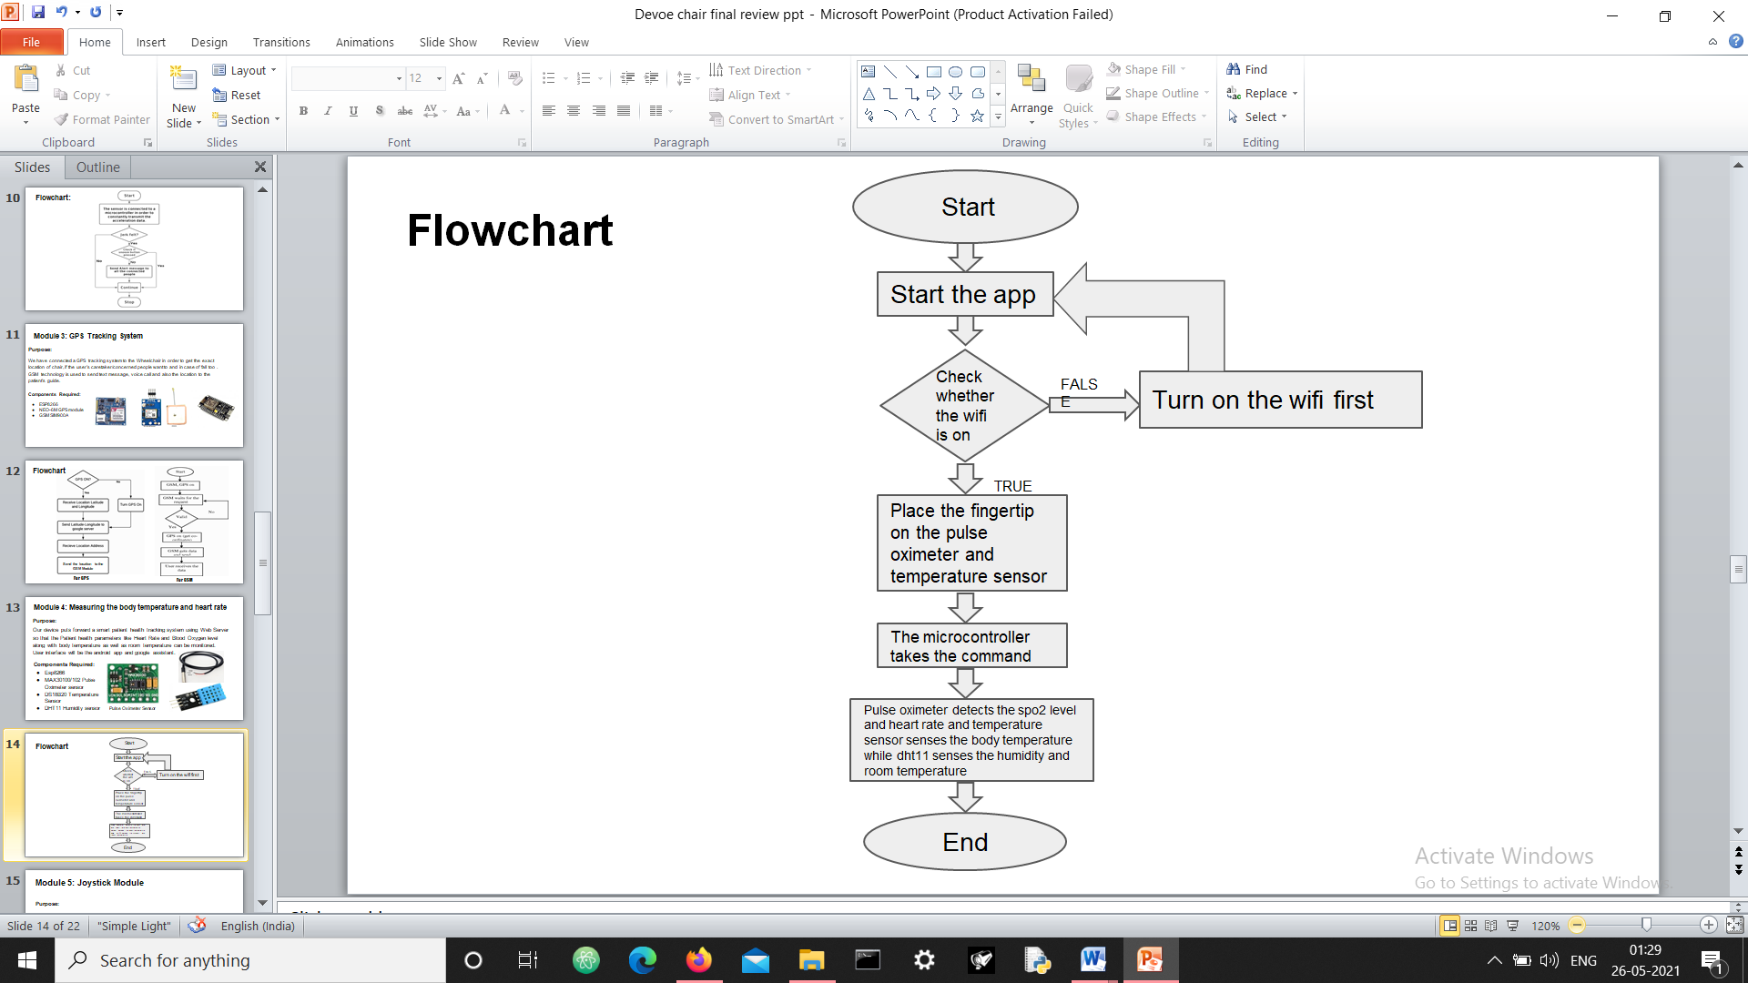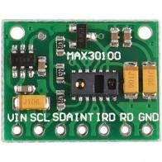

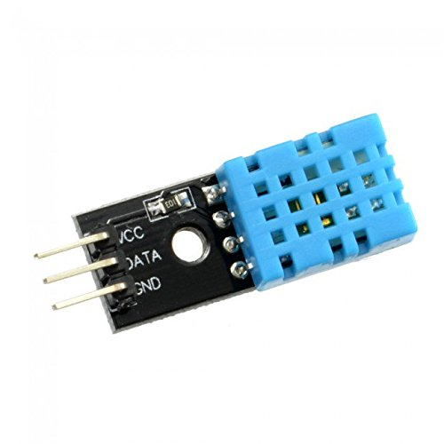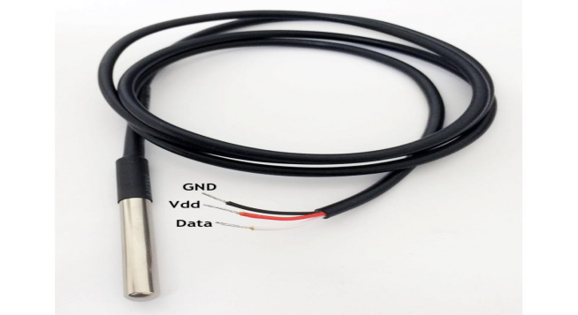



**Flowchart of health monitoring system**

**Module 5: Joystick Module**

This module is focused on movement of the chair.The movement will be controlled by the joystick.This will help the user to control the chair easily without depending on others.

Components Required:

The working of the joystick is simple. It is based on the principle of conversion of physical movement into a digital signal which when accepted by the device produces the same results on the screen.

The L298N is a dual H-Bridge motor driver which allows speed and direction control of two DC motors at the same time. The module can drive DC motors that have voltages between 5 and 35V, with a peak current up to 2A.

The servo motor is a closed-loop mechanism that incorporates positional feedback in order to control the rotational or linear speed and position. The motor is controlled with an electric signal, either analog or digital, which determines the amount of movement which represents the final command position for the shaft.

Arduino Uno Rev. 3 Microcontroller Board is based on the Microchip Technology ATmega328 8-bit Microcontroller (MCU). Arduino Uno features 14 digital input/output pins (six of which can be used as PWM outputs), six analog inputs, and a 16MHz quartz crystal.

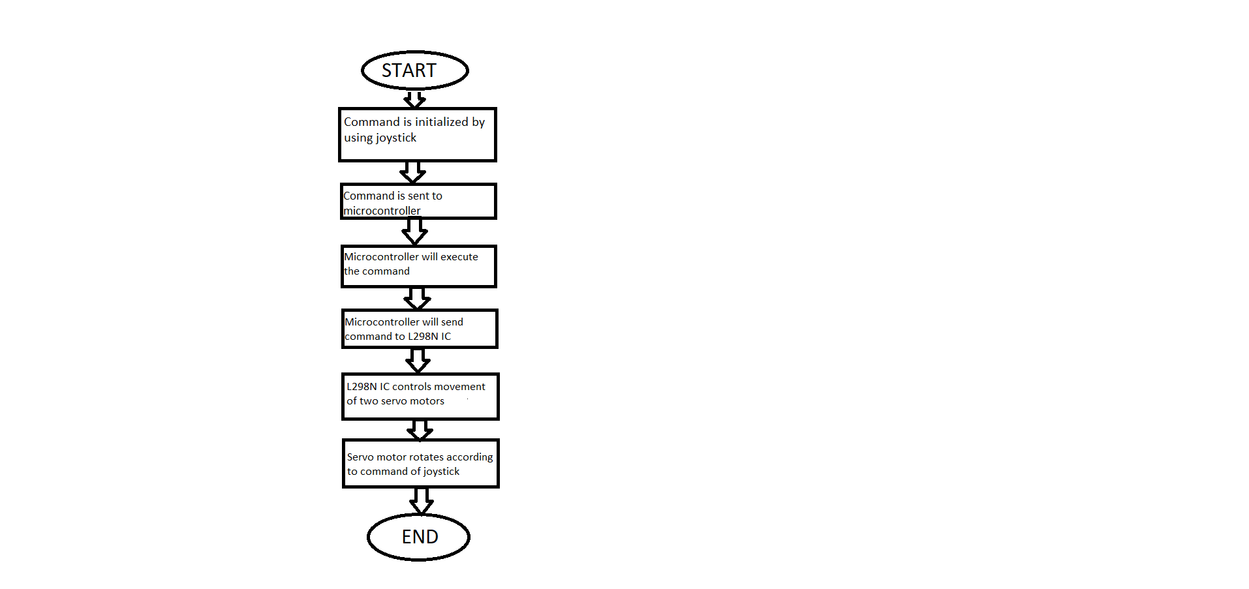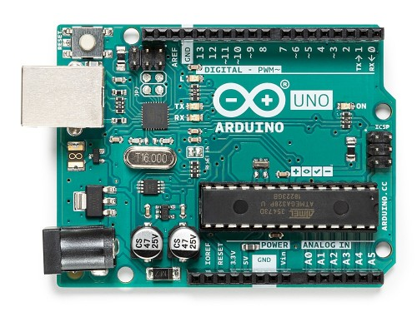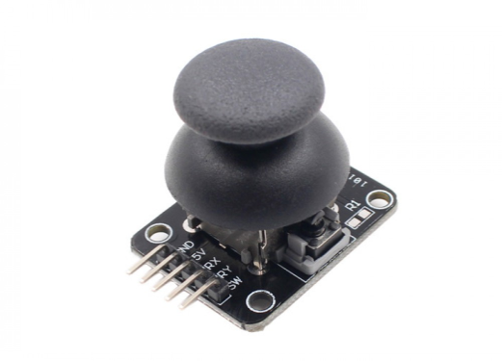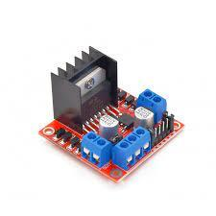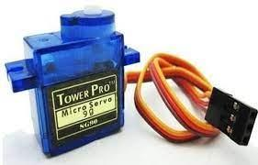

Flowchart: Working of Joystick Module

**Module 6: DEVOE CHAIR APP**

This app can be described in two parts: The side navigation bar of the app provides a user with features like: home-automation, body temperature monitoring, pulse, location, authentication and settings whereas the bottom navigation bar of the app provides information regarding the current updates of COVID-19, like: statistics, current news, hospitals, requirements etc. as it it the need of the hour.

**Side Navigation Bar:**

* **Home Automation** will allow us to connect the home appliances which could be later controlled by the use of our app providing an ease to the person in wheelchair.
* **Body Temperature** is crucially important when it comes to patients who are incapable of taking care of themselves. We have installed an in-built thermometer which will help them monitor their body temperature without much external help.
* **Pulse** is equally viable for any patient’s progress and thus an in-built heart rate monitor (HRM), a personal monitoring device that allows one to measure/display heart rate in real time or record the heart rate for later study. It is largely used to gather heart rate data while performing various types of physical exercise.
* **Location** of the wheelchair can also be monitored by the use of an in-built GPS tracker enabled in our app.
* **Authentication** includes login and logout of the application as per suitability.
* **Settings** will consist of font variations and sizes, along with themes, etc.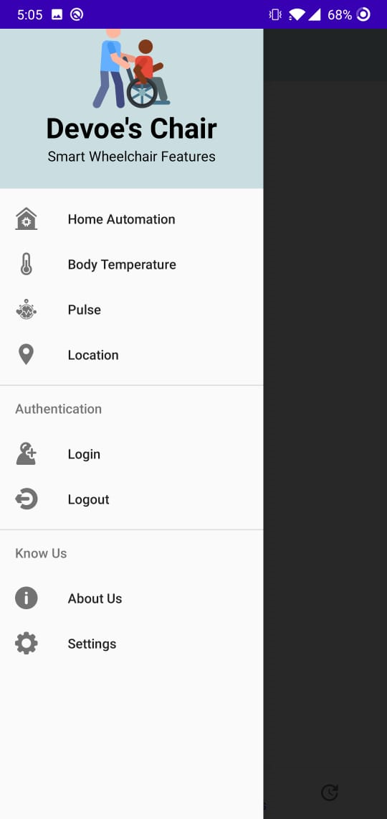

**Bottom Navigation Bar:**

* **HOME-** This will provide information regarding the on-going COVID situation such as news updates.
* **STATISTICS-** The rising number of cases, death toll, recovery rate, etc will all be provided here in this section.
* **HOSPITALS-** Information consisting of the locations of hospitals will be categorized here state wise and area wise so that a person can locate the nearest hospital facility.
* **UPDATES-** Requirement details like vaccine dose, oxygen and bed availability for patients in different parts of the country will be found in this part of the application so as to help the people stay updated.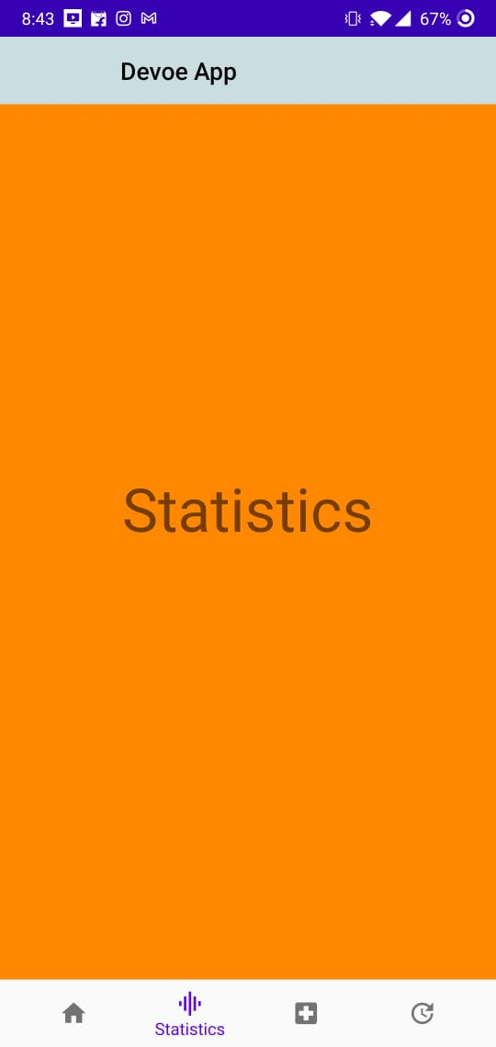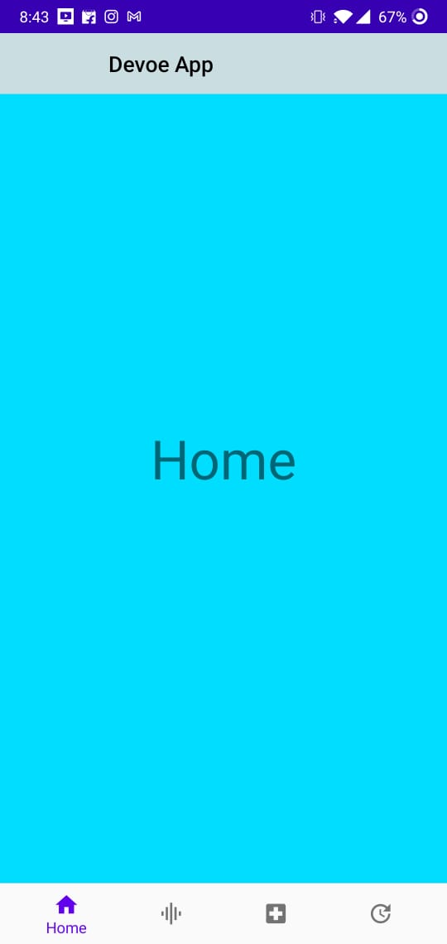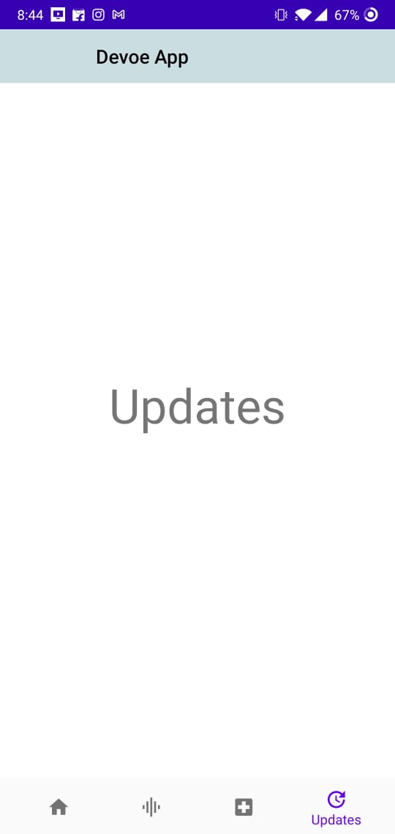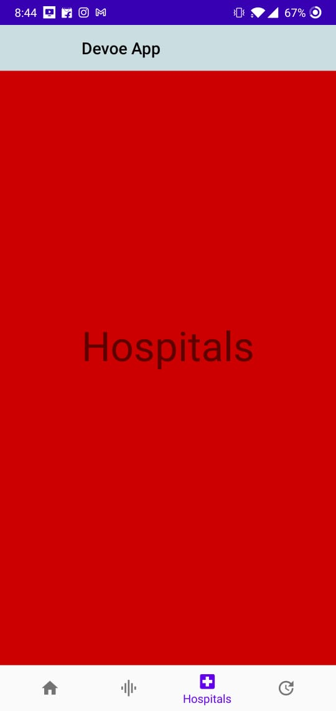

**Expected Results**

This project is based on IOT(Internet of Things). IOT allows object to be sensed and controlled remotely across existing network infrastructure,creating opportunities for more accuracy and improving efficiency.DeVoe’s Chair is a smart wheelchair which comes with a fall detection system,GPS tracking,sensing your body temperature,heart rate,intelligent picking along with a home automation system which can be controlled by google assistant or touch screen.

**Discussion:**

This project is based on IOT(Internet of Things).​ DeVoe’s Chair is a smart wheelchair which comes with a fall detection system, GPS tracking, sensing your body temperature, heart rate, SpO2 along with a home automation system which can be controlled by google assistant or touch screen.​ This chair is the future of care services around the globe, be it daycare for children or old age homes for elderly people.​ The chair provides comfort and security to anyone who is in a need to carry out the basic day to day life activities.

There’s been a project which is being made with a similar concept. In that project, a fall detection device was made which senses the jerk and alerts the relatives and loved ones of the user through Wifi.​ Home automation systems are made with NODE-MCU(ESP8266) or raspberry pi.This project provides home automation only with wifi. ​ In our project we are adding multiple modules. Firstly we are using ESP32 ; it has wifi as well as bluetooth modules. We are trying to use low cost components and adding different modules to the chair.

Additionally the COVID-19 features news updates, statistics which helps in creating awareness throughout the nation as a necessity.

Obstacle sensors can be added to detect hurdles in the path of the wheelchair. In fall detection we can use the GSM module to send messages on phone numbers also. In the future, we will try to add a robotic arm controlled by an app for picking objects along with voice controlled movement of the chair using google assistant.

**Individual Contribution**

* **AYUSHI JAIMANI**

I haveattempted to connect Android with Firebase Database where the data will be synchronized in real-time to every connected client. A Real-time database is capable of providing all offline and online services. These capabilities include accessibility from the client device, scaling across multiple databases, and many more. All of our clients will be able to share one Realtime Database instance and automatically receive updates with the newest data, when we build cross-platform applications with our iOS, and JavaScript SDKs. The best part is that whenever there will be a change in the database, it will be immediately reflected on all the devices connected to it. Along with this I have introduced authentication through OTP verification which will allow the user to securely login and logout without worrying about the malpractices. Preventing fake users, increased user value as well as increased security and user experience are just some of the many benefits of phone authentication. I have also contributed to the connection of the Heart Monitoring System with our Devoe’s App working alongside **Sushant Sharma** who handled the hardwareand Simulation of the module. I’ve also been responsible for the making of our Powerpoint Presentation of the Final Review.

* **SHIKHAR SRIVASTAVA**

I’ve built the layout of our Devoe’s App which consists of two navigation bars namely, side navigation bar and bottom navigation bar. The bottom navigation bar consists of fragments like Home, Update, Statistics and Hospitals. Here the Statistics and Updates fragments are connected with API which is provided by <https://www.covid19india.org/> . Home fragments will be linked with the API provided by WHO’s official website. When we open the side navigation bar we have provided the user with features like: home-automation allowing us to connect the home appliances which could be later controlled by the use of our app providing an ease to the person in wheelchair; I have installed an in-built thermometer which will help them monitor their body temperature without much external help; a personal monitoring device that allows one to measure/display heart rate in real time or record the heart rate for later study. It is largely used to gather heart rate data while performing various types of physical exercise. Location of the wheelchair can also be monitored by the use of an in-built GPS tracker enabled in our app.​ Authentication includes login and logout of the application as per suitability as well as settings that will consist of font variations and sizes, along with themes, etc.​ I have also contributed to the making of the Powerpoint Presentation.

* **ANUTEJ KARDELE**

We are connecting our application to google assistant through "Assistant". "Assistant" - is an app from google on play store which allows us to connect our own application to go assistant. Also, we have a code in our application which takes command from Google Assistant and does the work accordingly. For example: "Switch on the fan" command switches on the fan. NEEDS REPHRASE When you launch this application there is an option to link your app to the Google assistant. So when you link the application then you are able to control that application by just saying "I want to speak to Devoe's Chair". Now we can control our chair using Google assistant. Then we have a code in our application which takes command from Google assistant and does the following thing required. You may say "To switch on the fan" so now your code would know which button fan is controlled with so it would turn on the fan.

* **UTKARSH GUPTA**

I have made the **Fall Detection module** which will be a wearable device for the person using the wheelchair. I have made the Schematics of my module by using the Proteus Software. Components used in this module are: **NodeMCU** - For integrated Wifi and Bluetooth, **MPU6050** - Gyroscope+Accelerometer sensor, **GPS Module**, **GSM module,**  and I have done the Programming part using Arduino IDE.I have also contributed in making the Schematics of Home Automation Module, but the Hardware Part and Programming of Home Automation is done by KHUSHI RATHORE. I have researched about my Module and have provided the information while the formation of Presentation and Report.

* **ANJALI PRAJAPATI**

I have collected some theoretical material from the net about this project and collected resources for the project. I have also contributed in the programming of the GPS Tracking System to get the exact location of the person wearing the fall detection device and a GSM module to send text messages and have added flowchart of how it'll be sending text messages.

* **SUSHANT SHARMA**

I have contributed in making the **Health Monitoring System** for the person using the Wheelchair. It will be integrated with the Fall detection module, so that the user of the wheelchair will have to wear only one device which will determine his/her health conditions as well as Fall Detection. I have also done the coding part of this module. The components used in this module are: **DHT11** Temperature and **Humidity** sensor and a **Pulse Oximeter**.Apart from this I have also made the **Hardware** part of **Joystick module** for the movement of the wheelchair and I have researched and provided information about sensors to add in the presentation and report for Phase II.

* **KHUSHI RATHORE**

I have contributed in making the **Hardware** system of Home Automation System. In this module I have used **NodeMCU** as this board has integrated Wifi and Bluetooth so that no External Wifi module has to be used, **LED bulbs** for depicting the functioning of home automation, and apart from this to accomplish the working of my module through **Google Assistant** and **Blynk App**, I have used the **IFTTT website server** and **Blynk App**. The Programming Part is done using Arduino IDE.I have also researched the information regarding our project and made the Report and Presentation for Phase I and Phase II.

**Conclusion**

This wheelchair provides all the basic needs for a disabled person to be independent.This chair provides all the safety measures for the person.Obstacle sensors can be added detect hurdles in the path of wheelchair.In fall detection we can use gsm module to send message on phone number also.In future,we will try to add the robotic arm controlled by app for picking objects.Voice controlled movement of chair using google assistant.

**References:**

* [**https://circuitdigest.com/microcontroller-projects/iot-based-patient-monitoring-system-using-esp8266-and-arduino**](https://circuitdigest.com/microcontroller-projects/iot-based-patient-monitoring-system-using-esp8266-and-arduino)
* [**https://blog.asksensors.com/iot-cloud-based-gps-tracking-esp32-gps-neo-6m-module/#:~:text=Connect%20the%20GPS%20ground%20pin,computer%20through%20a%20USB%20cable**](https://blog.asksensors.com/iot-cloud-based-gps-tracking-esp32-gps-neo-6m-module/)**.**
* [**https://www.eso.org/public/outreach/eduoff/seaspace/docs/navigation/navgps/navgps-1.html#:~:text=It%20has%20several%20components%2C%20each,geographical%20position%20of%20the%20user**](https://www.eso.org/public/outreach/eduoff/seaspace/docs/navigation/navgps/navgps-1.html)**.**
* [**https://www.hackster.io/gatoninja236/esp32-fall-detector-b8ec6f**](https://www.hackster.io/gatoninja236/esp32-fall-detector-b8ec6f)
* [**https://circuitdigest.com/microcontroller-projects/iot-based-patient-monitoring-system-using-esp8266-and-arduino**](https://circuitdigest.com/microcontroller-projects/iot-based-patient-monitoring-system-using-esp8266-and-arduino)
* [**https://appuals.com/how-to-make-smart-home-automation-system-using- esp32-module/**](https://appuals.com/how-to-make-smart-home-automation-system-using-%20%20%20%20%20%20%20%20%20%20esp32-module/)
* [**https://iotdesignpro.com/projects/iot-based-fall-detection-system-using-nodemcu-esp8266-and-accelerometer-mpu6050#:~:text=To%20detect%20the%20fall%2C%20we,with%20IFTTT%20to%20send%20SMS**](https://iotdesignpro.com/projects/iot-based-fall-detection-system-using-nodemcu-esp8266-and-accelerometer-mpu6050#:~:text=To%20detect%20the%20fall%2C%20we,with%20IFTTT%20to%20send%20SMS)**.**
* [**https://www.hackster.io/ashshaks/diy-iot-fall-detection-using-nodemcu-9f18c9**](https://www.hackster.io/ashshaks/diy-iot-fall-detection-using-nodemcu-9f18c9)
* [**https://www.electronicwings.com/nodemcu/control-home-appliances-using-google-assistant**](https://www.electronicwings.com/nodemcu/control-home-appliances-using-google-assistant)
* [**https://ijict.iaescore.com/index.php/IJICT/article/view/11812**](https://ijict.iaescore.com/index.php/IJICT/article/view/11812)
* [**https://www.researchgate.net/publication/7449110_Smart_wheelchairs_A_literature_review**](https://www.researchgate.net/publication/7449110_Smart_wheelchairs_A_literature_review)